Dear Families,
As in the previous school year, students will be bringing home a class mascota/pet. This will be a similar activity to last year, however the worksheet and speaking structures will focus on new vocabulary.

During their week with the ‘mascota’ students will be expected to speak to the stuffed animal in Spanish as much as possible, as the animals only ‘speak’ Spanish. Although the amount of vocabulary your student will know will vary based on when in the school year they bring the animal home, some vocabulary your student could try could include:

Hola- Hello, Adiós- Goodbye, Buenos Días- Good Morning, Buenas Noches- Good Night
Gracias- Thank you , De Nada- You're welcome, Por favor- please

In addition to speaking to the animal in Spanish, students have a worksheet to fill out about their week with the animal. At the top there is a blank space for a picture of your student with the mascota. Actual pictures are prefered these will be displayed and it is fun for students to see pictures of themselves and others with the animal), however if it is not possible to get an actual picture, please feel free to have your student draw a picture of himself or herself doing something with the animal. The worksheet should be returned with the ‘mascota’, (the return date for the mascota will be listed at the bottom of the worksheet and the top of this paper).

The worksheet is all in Spanish, and students should fill in the answers in Spanish as much as possible (however English can be used when necessary). On the back of this page is a guide to how to respond to each of the questions. This assignment is meant to be a fun way to express themselves. Encourage your student to get creative with their answers!

If you misplace the worksheet, or explanation, both are available on my class website (which can be accessed via the Harvest site). http://goo.gl/uarH7L

Website QR Code:
BEFORE RETURNING THE MASCOTA TO SCHOOL: Por favor (please) give him/her a ride inside a pillowcase in your washing machine if at all possible ,
1) ¿Cómo te llamas? Me llamo _____________ (What is your name? My name is…..)Students should fill in the name they make up for the pet here.
2) ¿Cuál es tu videojuego favorito? Mi videojuego favorito es… (What is your favorite videogame? My favorite videogame is…) Students should answer with their favorite videogame. If they don’t like them, they can write ‘No me gusta’.
3) ¿Qué siempre tienes que hacer que no te gusta mucho? No me gusta...(What do you always have to do, that you don’t like to do? I don’t like…) this is a bit tricky, but a good challenge question. Generally students answer with a chore. (example: No me gusta lavar los platos/ I don’t like to wash the dishes). I encourage using Google Translate, or students can answer in English.
4)¿Cuál es tu película favorita? Mi película favorita es (What is your favorite movie? My favorite movie is…). Students can list a movie they think is the animal’s favorite, or a favorite movie.
5)¿Te gusta la música? Sí me gusta la ______ (Do you like music? Yes, I like …). Students can fill in the missing word (música). If they do not like music, they can cross out the ‘sí’ and write ‘no’.
6)¿Cuál tipo de música te gusta? Me gusta la música de…(What type of music do you like? I like the music of…). Students should write the type of music they like (Rock, Pop, Country, etc.)
7) Mi equipo favorito es/ My favorite team (sports) is: Here students can decide what the animals favorite sport team is by listing the team they support (if they have one).
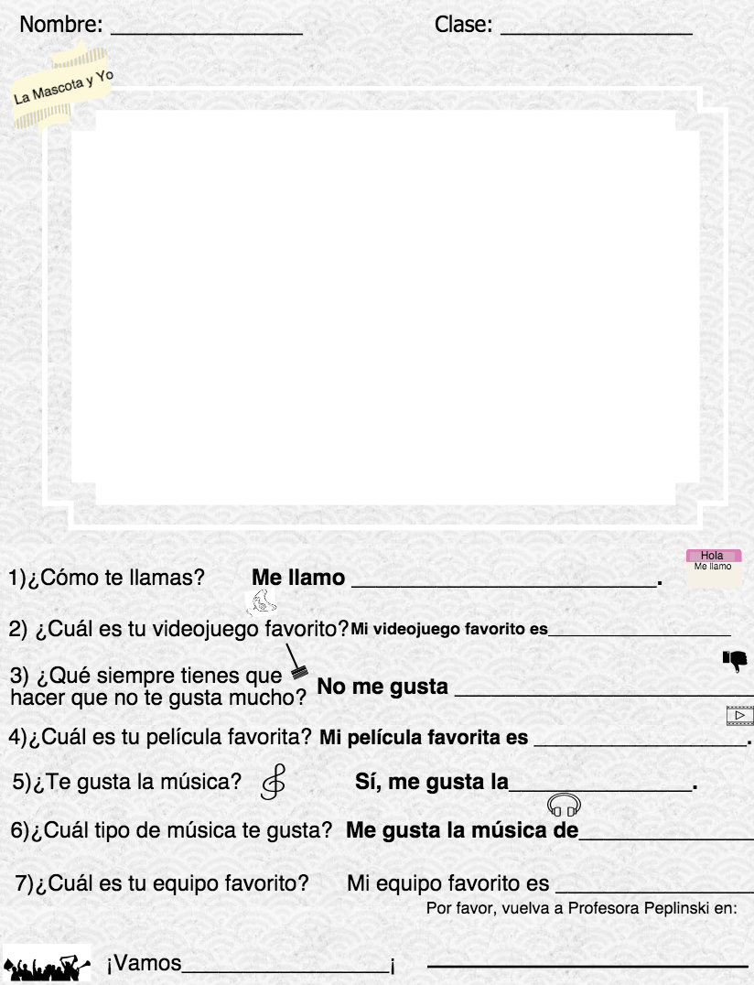
¡Vamos_____________! At the bottom of the worksheet it says ¡Vamos ________________! This is one way to cheer for a team in Spanish. Students can insert their favorite team name here. For example: ¡Vamos Michigan!, means ‘Let’s Go Michigan’!. Your son or daughter could also put the color of their team (¡Vamos azul!) Try cheering for your favorite team in Spanish at home!

Please remind your child to be patient as they wait for their turn to take the pet home, it will take most of the school year for all students to receive the mascota. Thank you for your support, and as always, please contact me with questions or concerns.
Sinceramente,
Erica M. Peplinski

